第一 环境（doker）

一 组件
分布式存储+分布式计算+分布式消息中间件
- zookeeper：注册中心，暂服务于kafka。
- kafka：消息中间件，适合批量拉取和批量提交offset，以及有后面与之匹配的各种插件，是核心之一。
- kafka-ui：用于做kafka监控。
- kafka-connect：用于消费kafka消息，并进行数据转换/压缩/S3落盘等操作。
- minio：分布式存储，可以替换为AWS。
- trino：分布式计算框架。
- iceberg-rest：Iceberg 表的元数据管理rest api服务（和hive metadata对标）。

二 docker-compose.yml
本地测试，使用docker做最小配置，用于测试方案可行性，实际中可以替换为以AWS为基础的真实环境
本地工程目录：/workspace-bigdata/offline/kafka-s3-demo

YAML
version: '3.8'
services:
# -------------------------------
# 0) Zookeeper & Kafka & Connect
# -------------------------------
zookeeper:
image: confluentinc/cp-zookeeper:7.5.0
container_name: zookeeper
environment:
ZOOKEEPER_CLIENT_PORT: 2181
ZOOKEEPER_TICK_TIME: 2000
kafka:
image: confluentinc/cp-kafka:7.5.0
container_name: kafka
depends_on:
- zookeeper
ports:
- "9092:9092"
- "19092:19092"
environment:
KAFKA_BROKER_ID: 1
KAFKA_ZOOKEEPER_CONNECT: zookeeper:2181
KAFKA_LISTENERS: PLAINTEXT_INTERNAL://0.0.0.0:9092,PLAINTEXT_EXTERNAL://0.0.0.0:19092
KAFKA_ADVERTISED_LISTENERS: PLAINTEXT_INTERNAL://kafka:9092,PLAINTEXT_EXTERNAL://localhost:19092
KAFKA_LISTENER_SECURITY_PROTOCOL_MAP: PLAINTEXT_INTERNAL:PLAINTEXT,PLAINTEXT_EXTERNAL:PLAINTEXT
KAFKA_INTER_BROKER_LISTENER_NAME: PLAINTEXT_INTERNAL
KAFKA_OFFSETS_TOPIC_REPLICATION_FACTOR: 1
KAFKA_AUTO_CREATE_TOPICS_ENABLE: "false"
KAFKA_LOG_RETENTION_HOURS: 168
# --- 单机开发环境必配：事务日志副本数/ISR ---
KAFKA_TRANSACTION_STATE_LOG_REPLICATION_FACTOR: 1
KAFKA_TRANSACTION_STATE_LOG_MIN_ISR: 1
kafka-ui:
image: provectuslabs/kafka-ui:latest
container_name: kafka-ui
ports:
- "8080:8080"
depends_on:
- kafka
environment:
KAFKA_CLUSTERS_0_NAME: "local"
KAFKA_CLUSTERS_0_BOOTSTRAPSERVERS: "kafka:9092"
connect:
image: confluentinc/cp-kafka-connect:7.5.0
container_name: connect
depends_on:
- kafka
ports:
- "8083:8083"
environment:
CONNECT_BOOTSTRAP_SERVERS: "kafka:9092"
CONNECT_REST_ADVERTISED_HOST_NAME: "connect"
CONNECT_REST_PORT: "8083"
CONNECT_GROUP_ID: "connect-cluster"
CONNECT_CONFIG_STORAGE_TOPIC: "connect-configs"
CONNECT_OFFSET_STORAGE_TOPIC: "connect-offsets"
CONNECT_STATUS_STORAGE_TOPIC: "connect-status"
CONNECT_CONFIG_STORAGE_REPLICATION_FACTOR: "1"
CONNECT_OFFSET_STORAGE_REPLICATION_FACTOR: "1"
CONNECT_STATUS_STORAGE_REPLICATION_FACTOR: "1"
# key 用字符串
CONNECT_KEY_CONVERTER: "org.apache.kafka.connect.storage.StringConverter"
CONNECT_KEY_CONVERTER_SCHEMAS_ENABLE: "false"
# value 用 JsonConverter + schema（为了后面 Parquet）
CONNECT_VALUE_CONVERTER: "org.apache.kafka.connect.json.JsonConverter"
CONNECT_VALUE_CONVERTER_SCHEMAS_ENABLE: "true"
# 插件路径必须包含 confluent-hub 目录
CONNECT_PLUGIN_PATH: "/usr/share/java,/usr/share/confluent-hub-components,/connect-plugins"
volumes:
- ./plugins:/connect-plugins
# 关键：启动时先安装 S3 插件，再启动 connect
command:
- bash
- -c
- |
echo "Installing S3 sink connector from Confluent Hub..."
confluent-hub install --no-prompt confluentinc/kafka-connect-s3:latest
echo "Starting Kafka Connect..."
/etc/confluent/docker/run
# -------------------------------
# 1) MinIO (S3 Object Storage)
# -------------------------------
minio:
image: minio/minio:latest
container_name: minio
environment:
MINIO_ROOT_USER: admin
MINIO_ROOT_PASSWORD: admin12345
command: server /data --console-address ":9090"
ports:
- "9000:9000"
- "9090:9090"
volumes:
- ./minio-data:/data
# -----------------------------------------------
# 2) Iceberg REST Catalog (取代 Hive Metastore)
# -----------------------------------------------
iceberg-postgres:
image: postgres:15-alpine
container_name: iceberg-postgres
environment:
POSTGRES_DB: iceberg # Catalog 库名
POSTGRES_USER: iceberg # 用户名
POSTGRES_PASSWORD: iceberg123 # 密码
volumes:
- ./iceberg-pg-data:/var/lib/postgresql/data
iceberg-rest:
image: tabulario/iceberg-rest:latest
container_name: iceberg-rest
depends_on:
- minio
- iceberg-postgres
environment:
# 使用 Postgres 作为 Iceberg Catalog 元数据库（更稳定，替代默认的 SQLite）
CATALOG_URI: jdbc:postgresql://iceberg-postgres:5432/iceberg?user=iceberg&password=iceberg123
# catalog 仓库根目录，保持 s3:// 前缀
CATALOG_WAREHOUSE: s3://warehouse/
# 走 S3FileIO，而不是默认 Hadoop FileIO
CATALOG_IO__IMPL: org.apache.iceberg.aws.s3.S3FileIO
# S3(MinIO) 相关配置 —— 注意是 CATALOG_S3_* 前缀
CATALOG_S3_ENDPOINT: http://minio:9000
CATALOG_S3_PATH__STYLE__ACCESS: "true"
# AWS SDK 会从这几个环境变量里拿 AK/SK
AWS_ACCESS_KEY_ID: admin
AWS_SECRET_ACCESS_KEY: admin12345
AWS_REGION: us-east-1
ports:
- "8181:8181"
# -------------------------------
# 3) Trino Coordinator
# -------------------------------
trino-coordinator:
image: trinodb/trino:latest
container_name: trino-coordinator
depends_on:
- iceberg-rest
- minio
ports:
- "8085:8085"
volumes:
- ./trino/coordinator:/etc/trino
- ./trino/catalog:/etc/trino/catalog
# -------------------------------
# 4) Trino Worker Nodes
# -------------------------------
trino-worker-1:
image: trinodb/trino:latest
container_name: trino-worker-1
depends_on:
- trino-coordinator
volumes:
- ./trino/worker:/etc/trino
- ./trino/catalog:/etc/trino/catalog
trino-worker-2:
image: trinodb/trino:latest
container_name: trino-worker-2
depends_on:
- trino-coordinator
volumes:
- ./trino/worker:/etc/trino
- ./trino/catalog:/etc/trino/catalog
# -------------------------------
# Proper network definition
# -------------------------------
networks:
default:
name: iceberg_net
driver: bridge

配置已验证可用，如个别容器启动有问题，大概率是被该容器依赖的容器没初始化完成，手动重启一下该服务即可。

三 插件kafka-connect-s3准备

2-1 connect插件
- 打开浏览器：https://www.confluent.io/hub/confluentinc/kafka-connect-s3?utm_source=chatgpt.com
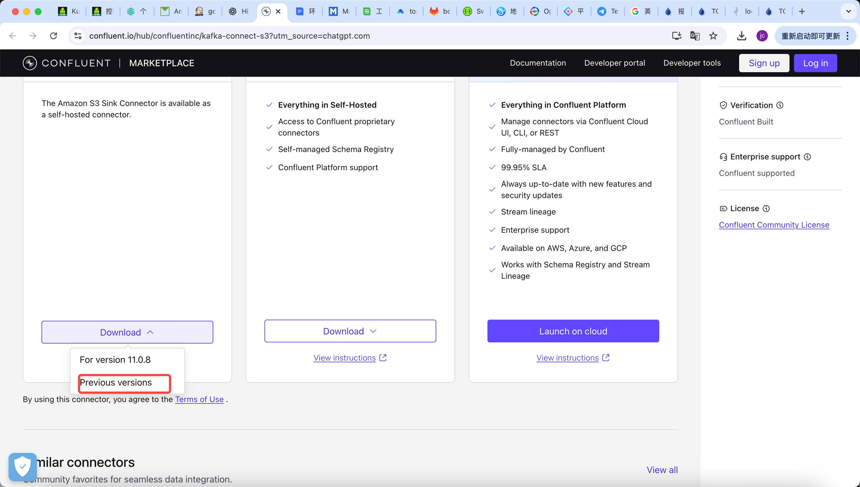
- 根据confluentinc/cp-kafka-connect:7.5.0的版本配置，找到对应的插件并下载，我用的是10.5.23版本
- 在docker-compose.yml的同级目录下新建文件夹plugins
- 将下载的插件复制到plugins并解压

2-2 iceberg插件
- 浏览器打开：https://github.com/databricks/iceberg-kafka-connect/releases?utm_source=chatgpt.com
- 下载iceberg-kafka-connect-runtime-0.6.19.zip
- 将下载的插件复制到plugins并解压

四 维护
Plain Text
// 启动容器
docker-compose up -d
// 查看容器状态
docker ps
// 查看插件加载状态
curl http://localhost:8083/connector-plugins
// 停止容器
docker-compose down

五 确认服务是否正常
